**A Note from New Lane PTA** 

**Gina Pasquarella,** President ** Lynn McMillin,** Vice President **Christina Klinger,** Vice President

**Melissa Foti,** Treasurer **Donna Boshart ,** Recording Secretary **Lynn Mitchell,** Corresponding Secretary

The New Lane Parent Teacher Association (PTA) has many exciting events planned for your children this year! There are lots of ways that you can support the PTA and its activities: one way is by becoming a member. The annual membership fee is $**10.00**, of which $4.00 goes directly to NYS PTA and the remaining $6.00 is used to support the many activities and events that our school’s PTA sponsors for your children.

**What does it mean when you join the PTA?**

* Are you required to attend meetings? No.
* Are you required to volunteer? No.
* Are you required to attend all events? No.

**Your membership in PTA means you are:**

* Making a difference in the lives of your children
* Saving money on movie tickets, dining, sports events, concerts and much more. Check out the growing list of Member Benefits on the NYS PTA website at <http://www.nyspta.org>
* Able to vote for important PTA issues.
* Helping to continue PTA-sponsored events at our school, such as Arts in Education programs, our MVP Dinner Dance, Fall Family Fun Night, PARP (a literacy program), Book Fairs, Citizen-of-the-Month and so much more!

Supporting the PTA isn’t just for parents/guardians! Your student can have his/her own membership. In addition, a membership is a great way for grandparents, godparents, aunts, uncles and friends to support your child’s school. If you have any questions, please don’t hesitate to contact us at [newlanememorialpta@gmail.com](mailto:newlanememorialpta@gmail.com).

**PTA memberships can also be purchased online at New Lane Memberhub store by scanning QR code below.**

Thank you for your support,

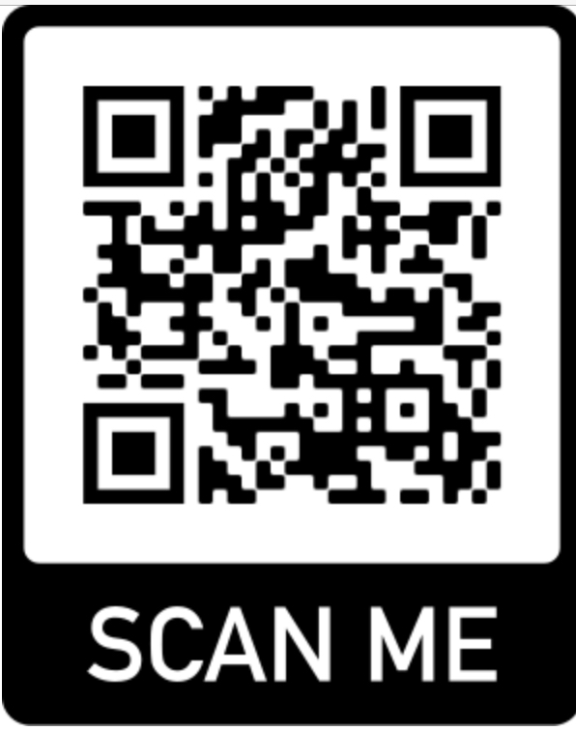New Lane Memorial PTA

——————————————————————————————————————————— Please make membership checks payable to “New Lane Memorial PTA”

Member name: _______

Address:

Phone #: Mobile#:

E-mail: _______

Student’s Name:

Grade: Teacher’s Name: